Step 1: go to **https://careercenter.anitab.org/**

On top Nav bar Click on **Job Seeker** then click on **manage resume.**

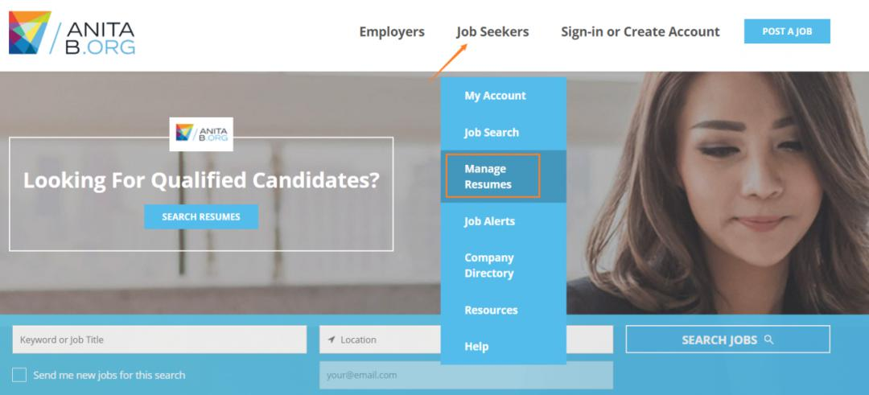

Step 2: Because we want to upload our resume for free, Click on **Guest User** **Login**

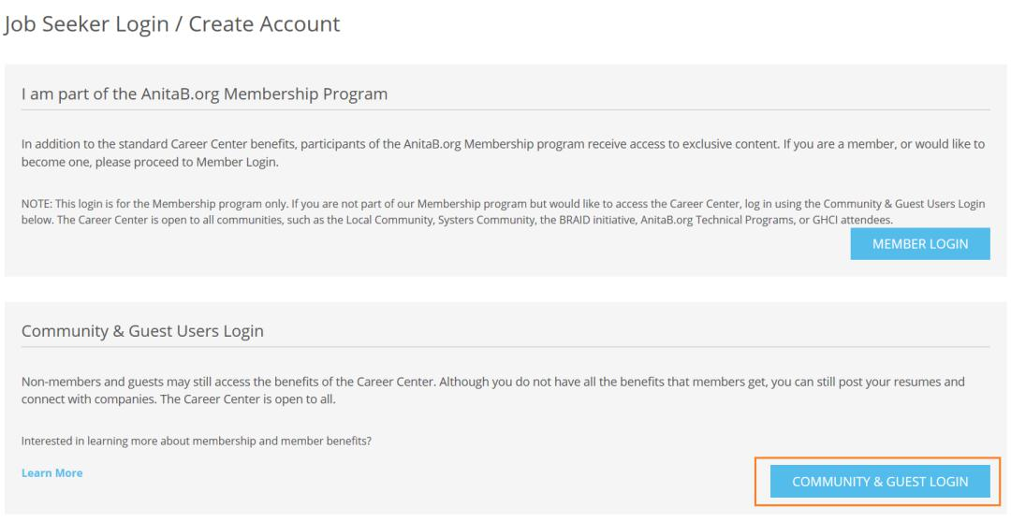

Step 3: Fill out the register information on the right-side of the website:

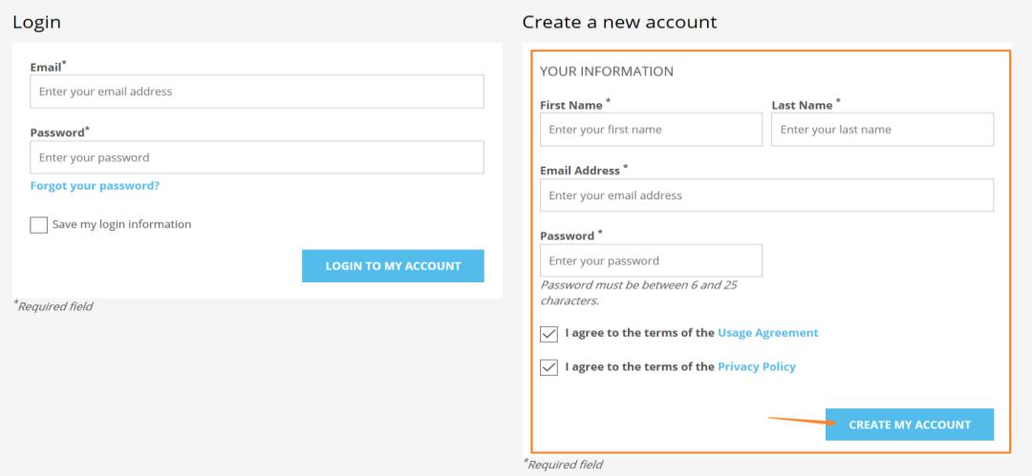

Step 4: There will be three resume data, the second and third are free, register and upload your resume to both **Community and Virtual GHC Resume** **database**

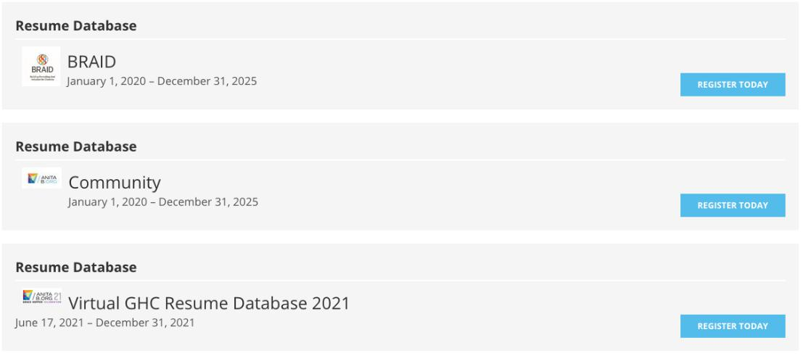

Step 5: After you completed the registered of of resume database, upload your resume scroll down to the bottom of page, and upload your resume to the database.

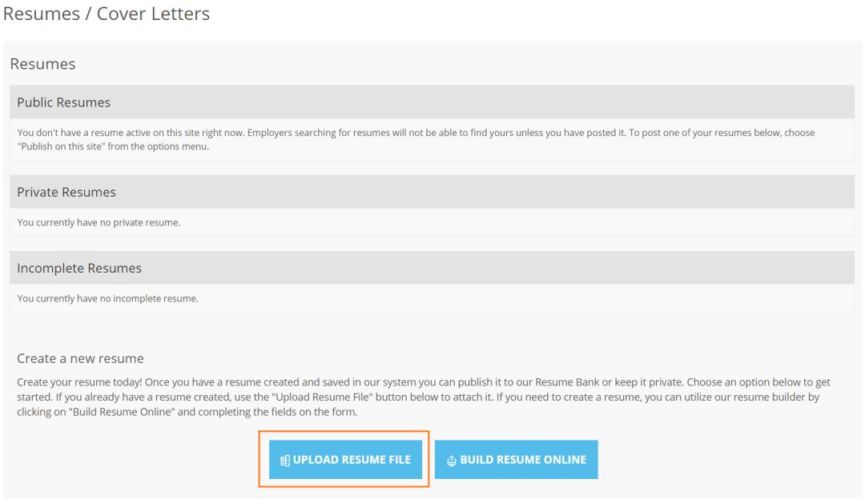

Step 6: After you completed all those step, if the recruiter like your resume they will email your and ask you to apply to the company.